Work report 31 aug 2021

Today I have trained the mask rcnn syncbn model till 49600 epoch

The evaluation results are as follows

1. Test Data

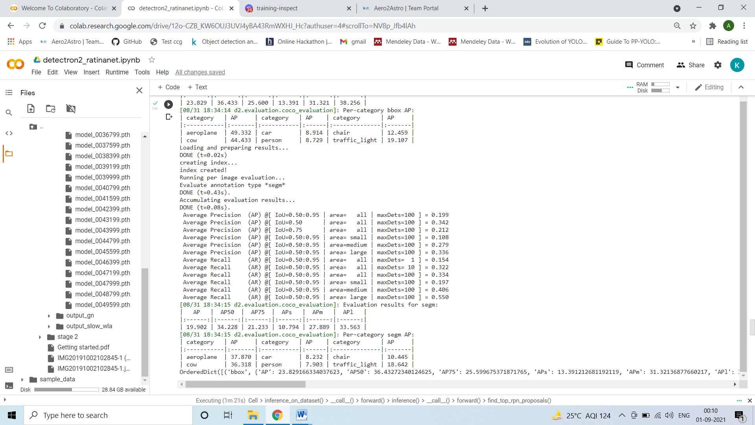

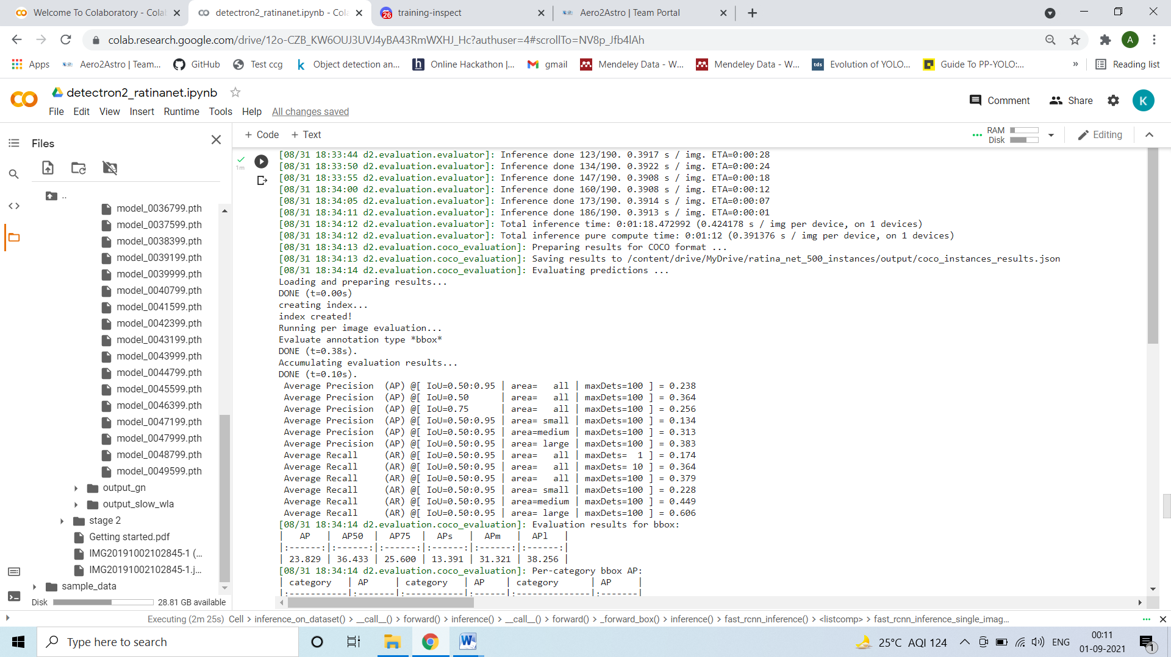

Train

